# Lesson 6 – 3D Visualization and 3D Animation

## GENERAL INFORMATION

For this exercise, we will leave the 2D world, and break into the 3D world. First, you will learn how to set up and display spatial information in three dimensions. This exercise ﬁnishes by creating a video of your animations that are to be uploaded onto Moodle.

## CREATING A 3D MAP

In ArcGIS Pro, a 3D map is called a scene. A scene can be viewed in either global or local mode. In global mode, the earth is drawn as a globe and your viewpoint is usually thousands of kilometres from the data. This view is best for very large study areas. In local mode, the earth is drawn in perspective. This view is best for small study areas, like for our data set. In the following, you will convert the map to a local scene.

### Preparation of the Buildings Layer

* As OpenStreetMap is not great for 3D data, our study data currently lacks height information. We will use the number of building levels to extrude the building footprints. Missing data will be completed by average values.

1. On the *Map*, select all building features that have a zero or a Null value assigned to the field *level_num* (this field was created in Lesson 1). Use the *Select by Attributes* tool.
2. Edit the *level_num* field of the selection by changing the value from *0* to *3* with the *Calculate Field*  tool.

### Extruding

* Insert a 3D map and extrude the building layer based on a building height calculation using the number of levels.

1. CLICK on the *Insert* tab on the ribbon. On the Project group, CLICK to expand the *New Map* dropdown menu and SELECT New Local Scene . An empty local scene will open.
2. Use the *Add Data* button  to add your *buildings* layer as well as the *roads* layer.
3. CLICK the *Feature Layer* tab on the ribbon (this tab is activated once You select a vector layer on the Contents pane). CLICK on Extrusion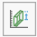. SELECT the option *Max Height* from the dropdown arrow (see the following figure).

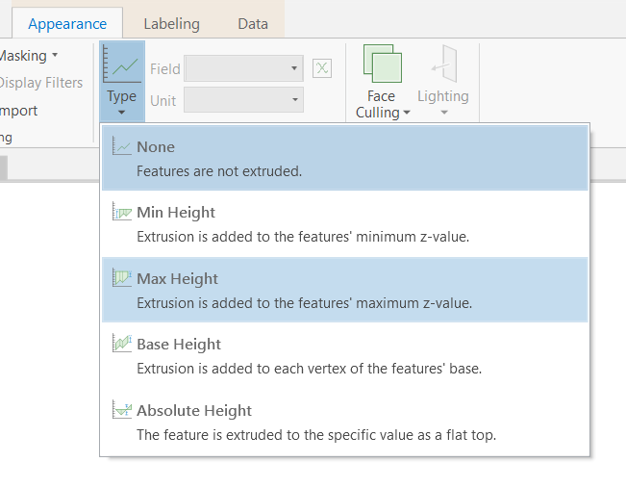

1. CLICK on the *Extrusion Expression*  button. The **Expression Builder** window opens. CHOOSE Arcade as Language type and TYPE $feature.level_num*4 into the *Expression* box. Confirm by CLICKING OK. This way, the buildings are extruded based on a 4 m height value per building level.

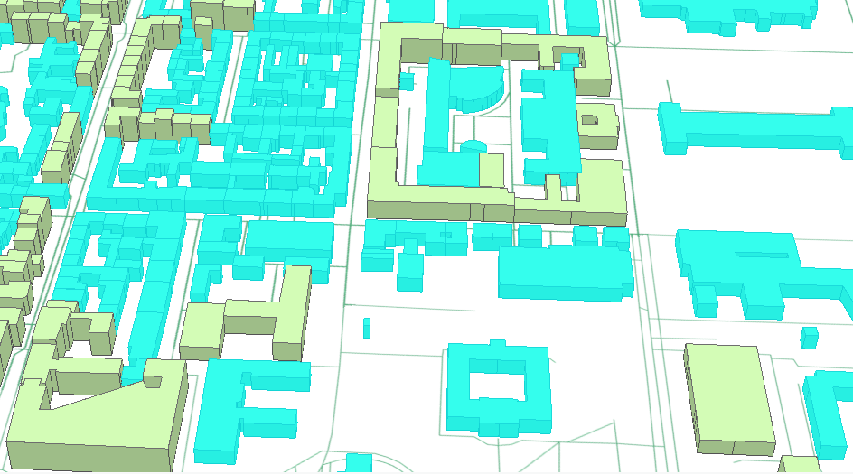

### Changing the Coordinate System of the Local Scene

* Change the map projection to UTM. Then, all newly added data will fit better to the previously edited study area data.

1. In the *Contents* pane, RIGHT-CLICK the *Scene* and CLICK *Properties*.
2. On the **Map Properties** dialog box, CLICK the *Coordinate Systems* tab.
3. CLICK to activate the *Current XY* WGS84 coordinate system.
4. Navigate on the *XY Coordinate Systems* Available list to *Projected coordinate system > UTM > Europe > ETRS 1989 UTM Zone 32N*.
5. CLICK *OK*. The local scene 3D features will be reprojected and redrawn to the UTM projection.

### Navigating in a Scene

* Get Yourself familiar with the control tools for navigating in a 3D scene.

1. On the navigator, which You find on the bottom left of the Scene pane CLICK the *Show Full Control* button. The navigator expands to show its full functionality.

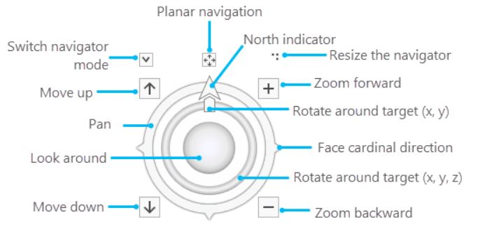

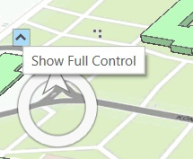

1. You can also use the following mouse functions to navigate through the scene.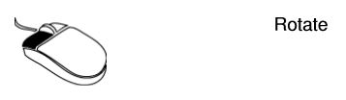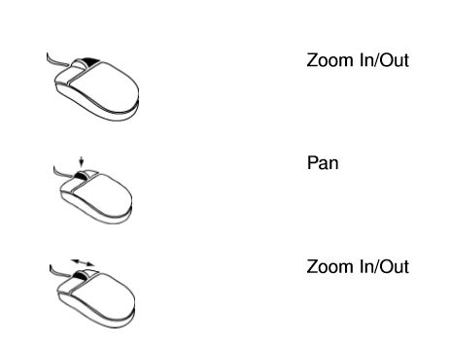

### Create New Features for a 3D Scene

* In this section, you shall create a group of new feature classes that we use for 3D Modelling.

1. To create a new Feature Class, open the *Catalog* pane by CLICKING *View > Catalog pane* 
2. In the *Catalog* pane, extend *Databases* and RIGHTCLICK on your geodatabase

* HOVER OVER *New.*
* And CLICK *Feature Class.*

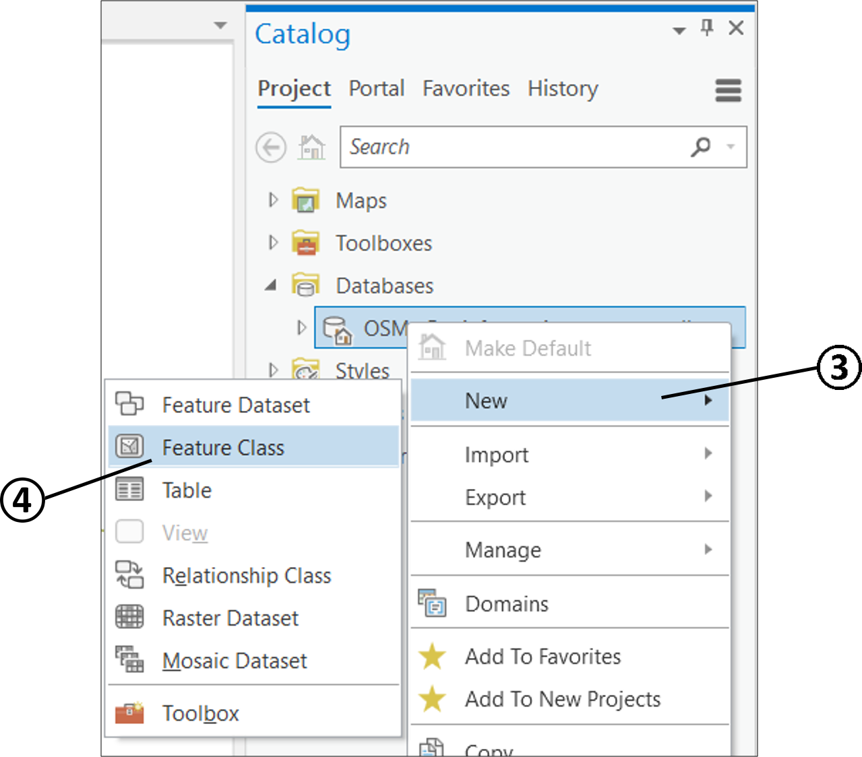

1. On the **Define** page of the opened wizard pane, type Treesfor the feature class in the *Name* text box.
2. Select *Point* as *Feature Class Type* using the dropdown menu.
3. UNCHECK the *M Value and CHECK the Z Value* of the *Geometric* and CLICK *Next.*
4. You can either go through all steps of the wizard or complete it by CLICKING *Finish.*

* Create the following four new feature classes using the same workﬂow:
  1. *StreetLights*, which will contain the street lamps,
  2. *ParkBenches,* which will contain the park benches,
  3. *OldPinakothek*, which will contain the anchor point for the Old Pinakothek,
  4. *TUM,* which will contain the anchor point of the TUM building.

### Digitizing new Features to the Scene

* Add the newly made feature classes and a georeferenced park cadastral plan to the 2D Map. Then, digitize trees, park benches and street lamps according to the cadastral plan.

1. Use the *Add Data* button  to add thelayers *Trees*, *StreetLights, and ParkBenches* to the Map.
2. Use the *Add Data* button  to add theraster layer *Park-cadastral.tif* to the Map.
3. Use *Edit>Create* to digitize new features for the trees, park benches, and street lamps according to the cadastral plan. See the following image for an explanation of the plan.

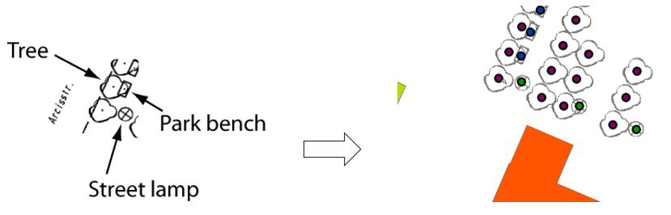

1. Use the *Add Data* button  to add thelayers *OldPinakothek*, and *TUM to the Map.*
2. Create the point for the *Old Pinakothek* layer. Locate this single point on the northeast building corner as shown in the following ﬁgure. Zoom into this corner for a precise result.
3. Create the point for the *TUM* layer. Locate this single on the northwest building corner of the Audimax, as shown in the following ﬁgure. Zoom into this corner for a precise result.

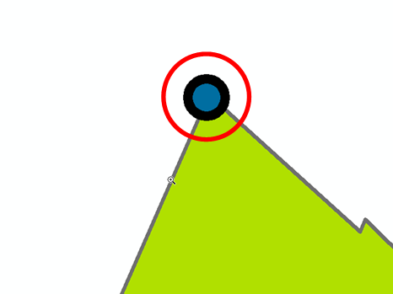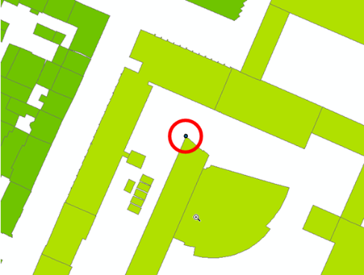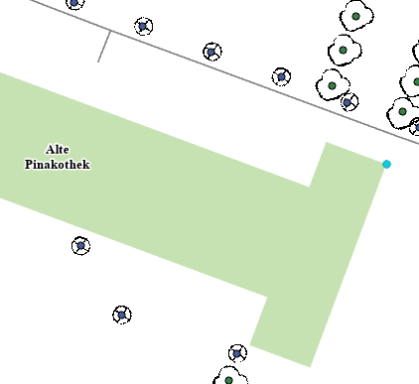

## 3D MARKER SYMBOLS

3D symbols are categorized under the marker symbol layers known as 3D model marker symbol layers. 3D model marker symbol layers are mainly used to emphasize symbols, especially point symbols on a map. They can be used to identify locations, routes or transportation utilized in an area symbolized in 3D form. The model for these markers can be derived from either built-in 3D symbols, or importing custom 3D symbols in ArcGIS Pro. ArcGIS Pro allows the importing of .3DS Max (*3ds), OpenFlight (*.flt), Wavefront (*.obj) and Collada (*.dae) formats.

### Using Built-In Marker Symbols

* The newly digitized features are to be symbolized with 3D marker symbols.

1. Switch back to the Scene. On the *Scene*, use the *Add Data* button  to add thelayers *Trees*, *StreetLights*, *ParkBenches,* *OldPinakothek*, and *TUM* to the Scene.
2. On the contents pane DOUBLECLICK the point symbol under *Trees* to open the *Symbology* pane.
3. On the *Gallery* section, CLICK on the far right dropdown-arrow to SELECT *All Styles* (instead of *Project Styles*).

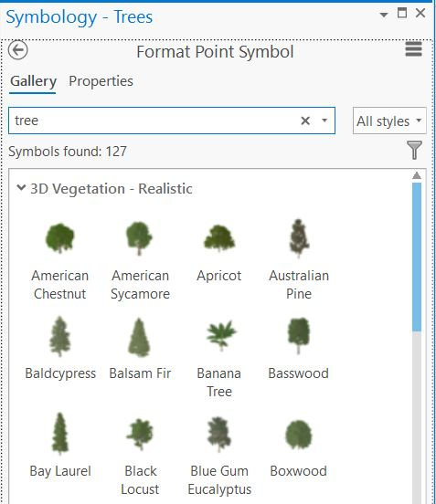

1. TYPE tree in the search box.
2. CLICK to select an appropriate Tree model to visualise the chestnut trees around the Old Pinakothek.
3. Once you zoom you will notice, that the Model´s symbol size is dependent on the scaling. To manage the scale of the 3D symbols, RIGHT-CLICK on Layer *Trees* on the *Contents* Pane and go to *Properties > Display* and CHECK *Display 3D Symbols in real-world units*.

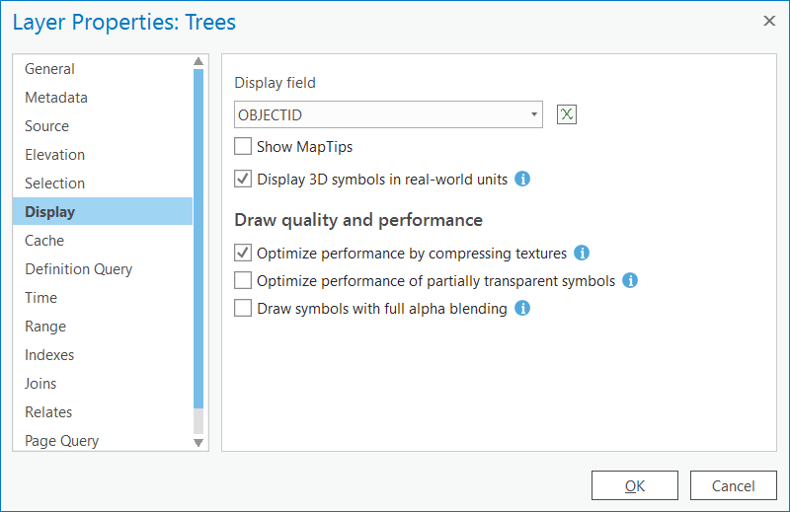

1. Back on the Symbology pane, under *Properties > Symbol > Appearance > Size* you can set a real-world *Size* in metres.

* Using the same workflow symbolise the street lights and the park benches. (The park benches orientation will be fixed later.)

### Classify the Park Benches According to their Orientation

* Currently, all park benches will be placed in the wrong angle. Therefore, orientate each line of park benches according to its own orientation.

1. Open the *Attribute Table* of the *ParkBenches* feature.
2. 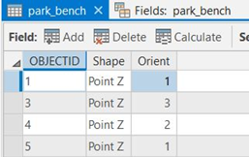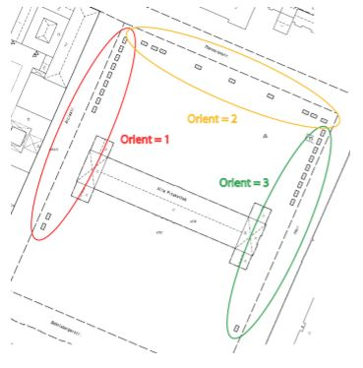Add a new ﬁeld to the Attribute table with the name *Orient* and edit the attributes. Assign three different values for the *Orient* field (see the following ﬁgures).
3. *Save* the editing and close the Attribute Table.
4. On the *Contents* pane, RIGHT-CLICK to open the **Symbology** pane. Under *Primary Symbology*, SELECT the *Unique Values* option.
5. Categorize the features in the layer *ParkBenches* with Symbology → Unique Values according to the attribute *Orient* (*Field 1*).
6. Symbolize each category of the point layer *ParkBenches* with a built-in 3D model style for Park Bench. Try searching using the keyword bench.
7. Adjust the *Rotation* values from the Format Point Symbol pane to orientate each line (=category) of the benches to the right direction. Adapt the model´s angle under *Properties > Symbol > Appearance > Angle.* You will have to give three individual angle values for the three categories.
8. Once you zoom you will notice, that the Model´s symbol size is dependent on the scaling. To manage the scale of the 3D symbols, RIGHT-CLICK on Layer in the *Contents* Pane and go to *Properties > Display* and CHECK *Display 3D Symbols in real-world units*.
9. Back on the Symbology pane, under *Properties > Symbol > Appearance > Size* you can set a real-world *Size* in metres.

* Symbolize the layer *StreetLights* using the same workflow as the Park benches.

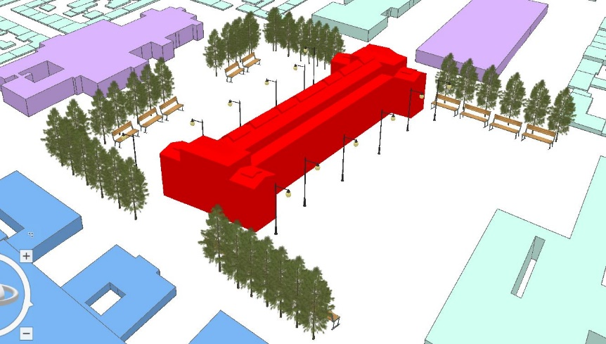

### Importing Custom 3D Symbols

* The current extruded TUM and Old Pinakothek Building are to be replaced with more sophisticated 3D models. Therefore, these buildings have to be marked / edited with a different category so they can be excluded from vision.

1. Open the *Attribute Table* of the *buildings* layer. Add a field named *Visibility* and save the new field.
2. Select all TUM buildings and the Old Pinakothek by *Interactive Selection*. Use the *Polygon* tool .
3. Calculate an individual value (i.e. *1*) for the field *Visibilit based on the* selected fields.
4. Symbolise the *buildings* layer by category as *Unique Values*. Remove the edited *Visbility* records and *all other values,* so only the TUM and the Old Pinakothek are hidden.
5. To add a custom 3D symbol for your TUM building, open the *TUM* layer´s symbology. CLICK *Properties* and the*Layers* icon . CLICK the top drop-down arrow and Select *3D model marker*.
6. In the *Appearance* section, CLICK the *File*button.
7. In the**Browse 3D model file** dialog box, select the desired custom symbol file *TUM.DAE* and CLICK *OK*.

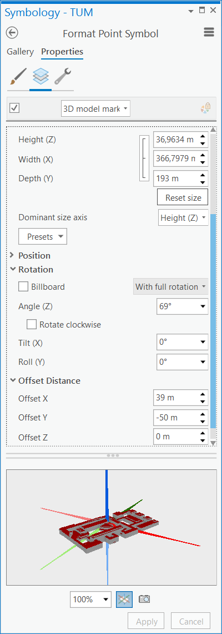

1. To manage the scale of the 3D symbols, RIGHT-CLICK on Layer in the *Contents* Pane and go to *Properties > Display* and CHECK *Display 3D Symbols in real-world units*.
2. Adjust the *Height, Width and Depth* values from the *Appearance* dropdown section. Set 193 *m* for *Depth*.
3. Also, adjust the *Angle (Z)* value to 69*°* under *Rotation.*
4. Under *Appearance*, UNCHECK the *Tint model* option.
5. Under *Position*, UNCHECK the *Override model origin with a custom anchor point* option.
6. Furthermore, specify an *Offset Distance* of 39 *m* for *X* and-50 *m* for *Y* to receive a good result.
7. CLICK to Apply the settings.
8. Symbolise the Old Pinakothek in the same way by using the *Old_Pinakothek.DAE* Model. (Remember to CHECK *Display 3D Symbols in real-world units.*) The model size is correct as it is. specify an *Offset Distance* of -79 *m* for *X* and1 *m* for *Y* as well as rotating it 1° in *Roll(Y)* to receive a good result. Use the settings according to the figure.

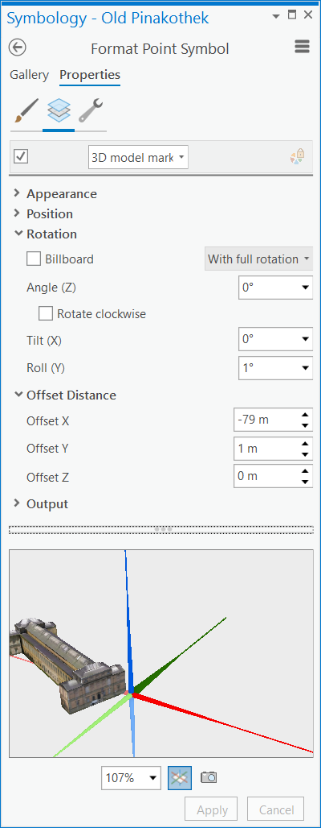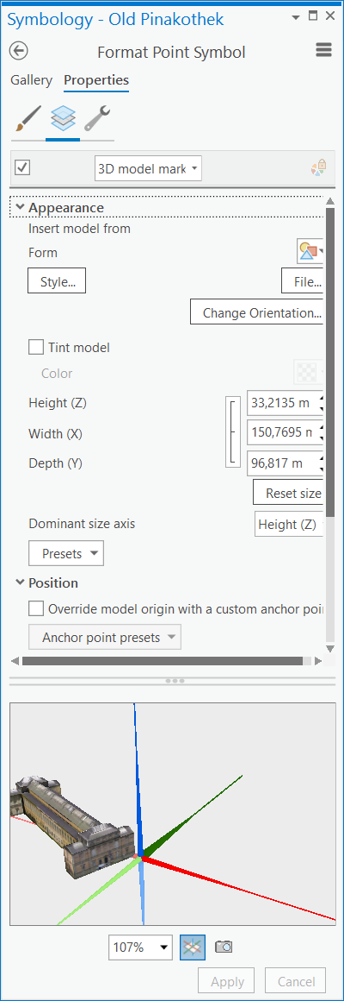

## CAPTURING AND DISPLAYING GNSS POINTS

* In this exercise, the task is to capture the positions of the listed monuments around the Alte Pinakothek and the TU Munich courtyard. You will work in groups on one GPS device. The results will be exported by the teacher in two files, which will be used for your own further work.

### Capturing GPS Positions of Monuments

**Overview of the GPS Device**

**Zoom In/Out**

Zoom can be used in Map view mode, to get a better overview of the region.

**Pan**

Pan can also be used in Map view mode, to get a better overview of the region or e.g. to switch between the fields in the Mark Waypoint dialog.

**Page**

There are six main pages:

Satellite gives you a view of the satellite positions above the horizon.

Trip Computer shows all interesting data about speed, distance, time etc.

Map shows your waypoint (marks) and imported maps.

Compass gives some short information with a compass rose.

Altimeter shows the elevation.

Main Menu for different kinds of helpful programs.

**Mark**

With the Mark Button, you can switch to the Mark Waypoint dialog field. With the Pan Button, you can switch the yellow bar between the fields. With the Entr (Enter) Button you start editing or saving your settings.

**Quit**

Make a break or go back to the higher level. The Quit Button can also be used, like the Page Button, to switch between the six different pages backward.

**Enter**

Save and start editing waypoints.



**Capturing GPS Point with the GPS Equipment**

**Initialize your GPS Device**

1. When turning on the GPS equipment, you will see the following interface.



2. Wait a few seconds until the GPS system has initialized with at least four satellites. The

accuracy will level off ±4 m.

**Tracking**



1. Switch to the main menu with the Page or Quit Button and select the submenu Tracks

with the Enter Button.

2. Set the Track Log to ON and leave the menu with Quit. The GPS device records your position the entire way. For the positions of the monuments, you require the manual measurement procedure marks.

3. Click the Page Button and switch the interface from Main Menu view to Map view.

1. *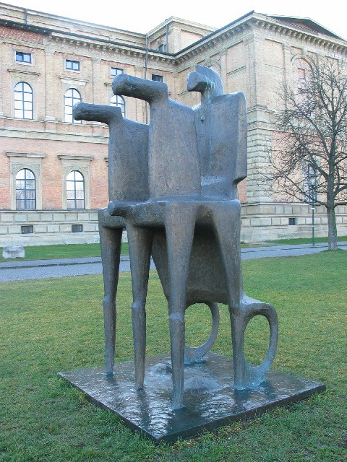Pipes*
2. *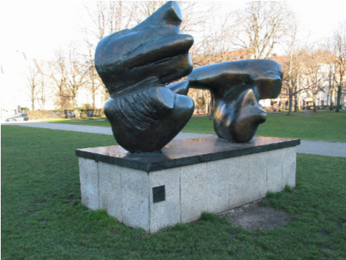Chariot*
3. *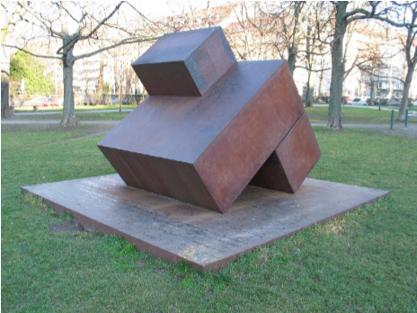Abstract Art*
4. *Double L-Form*
5. *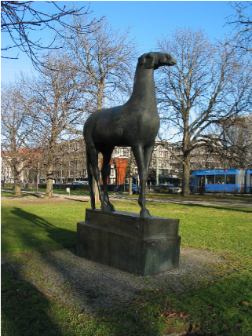Horse*
6. *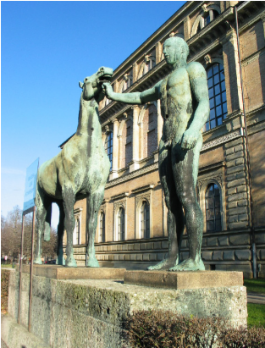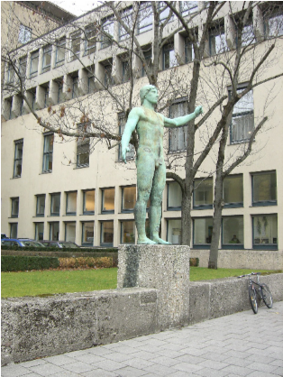Horseman with Horse*
7. *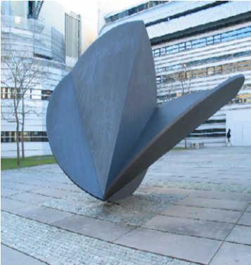Horseman*
8. *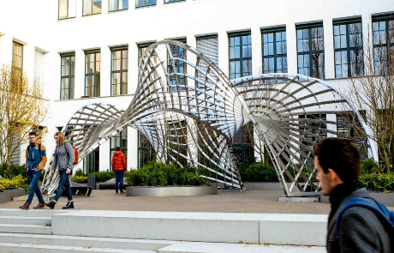Segment Circles*
9. *Inside/out Pavilion*

**Mark**

For the measuring of our monuments use the Mark mode to set a point or an average point on this position.

1. Click the Mark Button to get to the mark page and switch with the Entr Button to the field button Avg (Average Button). Take twenty measurements from each mark and stop counting while pressing Entr.

2. After saving, switch to the OK field and confirm with the Entr Button to save your Mark position.



### GPS Utility

GPS Utility is an application that provides management and manipulation of GPS information. It can be used to transfer data to/from a GPS receiver and store the data in PC files. This version is freeware.

1. Open GPS Utility

2. CLICK File > Open to open the file MONUMENTS.GPX from Moodle.



3. CLICK File >Save as to save the current file with the following file types: “DBF waypoint fileset (dbf + shp, shx)” (point shapefile) for the further process in ArcGIS Pro.

4. CLICK File > Open to open the file Track.GPX from Moodle.

5. CLICK File > Save As and save the current file with the file types:

“Shape trackpoint fileset (shp + shx, dbf)” (polyline shapefile) for viewing in ArcGIS Pro.

### Visualizing the Monuments in ArcGIS Pro

1. Add the *Monuments.shp* to the scene. Right now, the shapefiles do not have a specified georeference. Therefore, they do not appear in the correct space. The Shapefiles´ projection needs to be defined.
2. Open the *Geoprocessing* pane with *Analysis > Tools*. Search and open the tool *Define Projection*.
3. CHOOSE the Monuments layer and the geographic coordinate system WGS 1984 (as this is the geographic datum you used to capture the points). CLICK to *Run*.

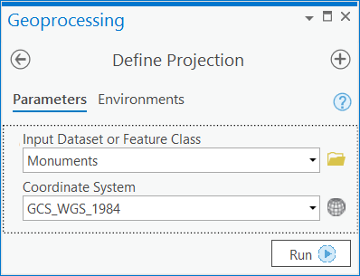

### Symbolise the Monuments in a Scene

1. On the *Contents* pane, make sure the *Monuments* are in the 3D Layers area.
2. As in previous sections categorise the monument features. Symbolise by *Unique Values* based on the Field *RECNUM*.

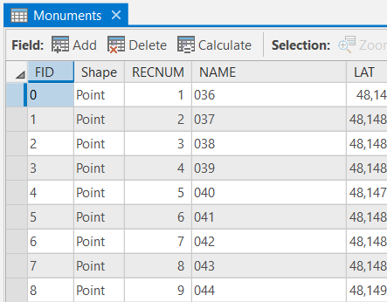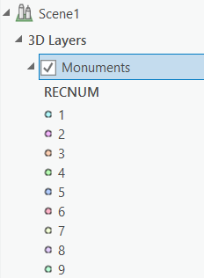

1. See the list of monuments with their associated numbering and height information:
2. 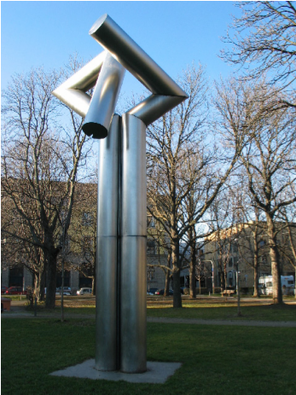*Pipes (7m height)*
3. *Chariot (3m height)*
4. *Abstract Art (3m height)*
5. *Double L-Form (2m height)*
6. *Horse (4m height)*
7. *Horseman with Horse (5m height)*
8. *Horseman (5m height)*
9. *Segment Circles (3m height)*
10. *Inside/out Pavilion (4m)*
11. To add a custom 3D symbol for a monument, open the *feature´s* symbology. CLICK *Properties* and the*Layers* icon . CLICK the top drop-down arrow and Select *3D model marker*.
12. In the *Appearance* section, CLICK the *File*button.
13. In the**Browse 3D model file** dialog box, select the desired custom symbol file *\*.DAE* and CLICK *OK*.
14. To manage the scale of the 3D symbols, RIGHT-CLICK on Layer in the *Contents* Pane and go to *Properties > Display* and CHECK *Display 3D Symbols in real-world units*
15. Back on Symbology Properties Layers, adjust the *Height* value from the *Appearance* dropdown section. You can look up approximate heights from the List of Monuments.
16. The models have no texture. Under Layers>*Appearance*, CHECK the *Tint model* option. Assign a representative colour for the model.
17. Under Layers>*Position*, CHECK the *Override model origin with a custom anchor point* option. CHOOSE on *Anchor point presets* the option *Centred Above*. That way, the model will not be placed under the virtual level surface of the other layers.

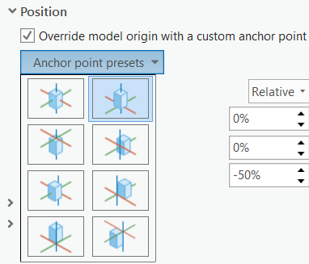

1. You can adjust the *Angle (Z)* valueunder Layers>*Rotation.*
2. Repeat steps 4 to 11 to complete the 3D Symbol Marking for all Monuments.

## 3D ANIMATION

Animations allow you to tell a story with your 2D and 3D GIS content, such as showcasing a critical region or by flying through a 3D view of the area and turning on analysis results. Animations are built by defining a small set of keyframes, within the view. A keyframe captures the state of the view including the camera position and visible layers. It contains the viewpoint, layer visibility, time, and range properties of the map, which can be used singularly or in combination depending on your needs. You can then export your animation to a common video format using ArcGIS Pro.

### Creating an Animation with Keyframes

* The **Animation** tab is a contextual tab, so it only appears when the active map or scene contains an animation.

1. To start working with animation, CLICK the *Add* button  in the *Animation* group on the *View* tab. This opens the **Animation** tab, which contains all of the tools for creating, editing, and exporting your animation.
2. Uncheck all the layers from the Content pane that you do not want in your video.
3. CLICK on *Timeline* in the Playback group of the *Animation* tab. The *Animation Timeline* pane will open at the bottom.
4. 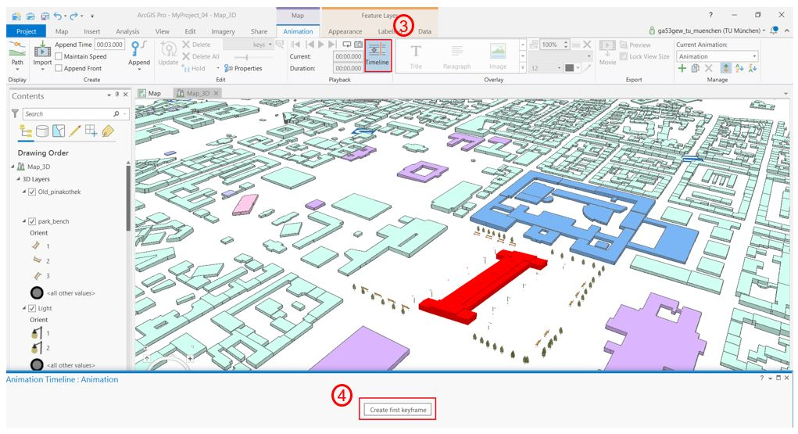Navigate through your scene and choose a frame for your starting point (the first scene of your animation) and CLICK on the *Create first keyframe* button in the *Timeline* pane.
5. Keep navigating to different viewpoints and capturing frames with the *Append Next Frame* button  (at least 3).
6. CLICK the *Play*  button on the *Playback* group to check your path. You can change the *Duration* of your video by changing the time also from the Playback group.
7. To add another keyframe in the middle of your video, drag the red bar in the timeline on the*Timeline* pane and navigate to your desired viewpoint.
8. CLICK *Insert* to add the new keyframe. Any keyframe can also by deleted when selected with the Button *Delete.*

### Animating Transparency for Layers

1. To change the transparency for a layer, select the layer in the *Contents* pane.

2. Go to the *Appearance* tab in the ribbon. In the Effects group, you change the layer transparency by moving the slider or typing a percentage.

3. You can repeatedly change the layer transparency and create new keyframes for your animation.

### Adding Text

1. Create a few keyframes focusing around the Old Pinakothek building.

2. Select a single keyframe from the **Keyframe Gallery** or select a group of keyframes.

3. In the *Overlay* group on the *Animation* tab, click the gallery drop-down arrow and CLICK *Title.* A text box appears on screen in an editable mode for the keyframes you selected.

4. Type Old Pinakothek and CLICK the *Close* button  in the upper corner to close on-screen editing.

5. In the *Edit* group on the *Animation* tab, CLICK *properties*. The *Animation Properties* pane opens.

6. Select *Old Pinakothek* from Overlay > Overlays in the *Animation Properties* pane.

7. CLICK on *Properties* in *Animation Properties* pane and change the appearance and position of the text as you like.

### Exporting an Animation

1. On the *Animation* tab, in the *Export*group, CLICK *Export Movie* . The **Export Movie** pane appears.

2. Choose thepreset option *YouTube* from the **Media Export Presets** group by clicking the thumbnail. (This quality is fine for submitting on Moodle.)

3. Set the location and file name for your video under *File Name*.

4. Optionally expand *File Export Settings* to review the output format. An MPEG4 movie is fine

5. Optionally expand *Advanced Media Export Settings* to review the output resolution and quality.

6. Click *Export*at the bottom of the **Export Movie** pane.

7. Upload the video onto Moodle.

Contents

Lesson 6 – 3D Visualization and 3D Animation 1

6.1 GENERAL INFORMATION 1

6.2 CREATING A 3D MAP 1

6.2.1 Preparation of the Buildings Layer 1

6.2.2 Extruding 1

6.2.3 Changing the Coordinate System of the Local Scene 3

6.2.4 Navigating in a Scene 3

6.2.5 Create New Features for a 3D Scene 4

6.2.6 Digitizing new Features to the Scene 5

6.3 3D MARKER SYMBOLS 6

6.3.1 Using Built-In Marker Symbols 6

6.3.1.1 Classify the Park Benches According to their Orientation 7

6.3.2 Importing Custom 3D Symbols 8

6.4 CAPTURING AND DISPLAYING GNSS POINTS 11

6.4.1 Capturing GPS Positions of Monuments 11

6.4.2 GPS Utility 14

6.4.3 Visualizing the Monuments in ArcGIS Pro 15

6.4.4 Symbolise the Monuments in a Scene 15

6.5 3D ANIMATION 17

6.5.1 Creating an Animation with Keyframes 18

6.5.2 Animating Transparency for Layers 18

6.5.3 Adding Text 19

6.5.4 Exporting an Animation 19